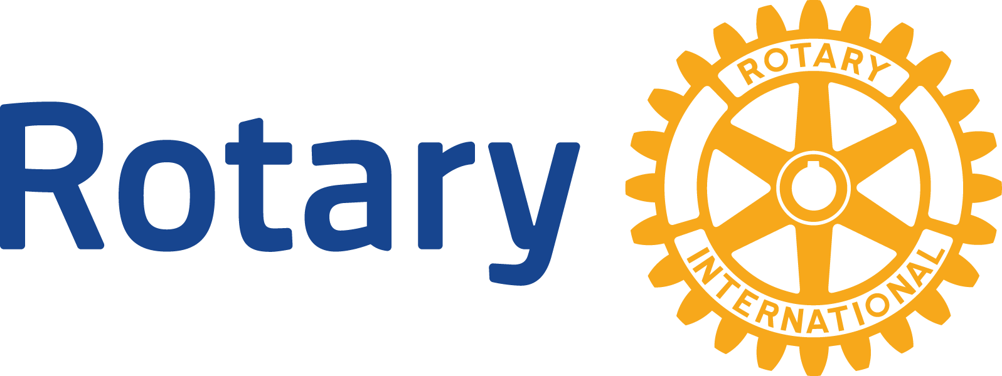
ENGLISH (EN)

GLOBAL GRANTS COMMUNITY ASSESSMENT RESULTS

Use this form to report community assessment findings to The Rotary Foundation when you apply for a global grant.
Assessing the strengths, weaknesses, needs, and assets of the community you plan to help is an essential first step in designing an effective and sustainable global grant project. See Community Assessment Tools for full instructions and helpful tips.
This form will help you report the results of your community assessment, and it’s required when you apply for any humanitarian or vocational training team grant. Complete a separate form for each beneficiary community (e.g., school, health care system, or village), using information that is both current and specific to each community. Remember, you can’t use global grant funds to cover the cost of doing an assessment, but you can use district grant funds.
Beneficiary community or institution
Click or tap here to enter text.

Groups in the community that would receive a clear, direct, and immediate benefit from the project
Click or tap here to enter text.

Beneficiaries’ demographic information, if relevant to the project
Click or tap here to enter text.

Who conducted the assessment? (check all that apply)
☐ Host sponsor members
☐ International sponsor members
☐ A cooperating organization
☐ University
☐ Hospital
☐ Local government
☐ Other Click or tap here to enter text.
Assessment dates
Click or tap here to enter text.

What methods did you use? (check all that apply)
☐ Survey
☐ Community meeting
☐ Interview
☐ Focus group
☐ Asset inventory
☐ Community mapping
☐ Other Click or tap here to enter text.
Who from the community participated in the assessment?
Click or tap here to enter text.

List the community needs you identified that your project would address.
1.
2.
3.
List any needs you identified that your project would not address.
1.
2.
3.
List the community’s assets, or strengths.
1.
2.
3.
Considering the needs and assets you listed, explain how you determined the project’s primary goal.
Click or tap here to enter text.

How would your project’s activities accomplish this goal?
Click or tap here to enter text.

What challenges have prevented the community from accomplishing the project’s goals?
Click or tap here to enter text.

How is the community addressing these challenges now?
Click or tap here to enter text.

Why are the project’s activities the best way to meet this community need?
Click or tap here to enter text.

